Template for IRCOBI Manuscript Preparation:

Put Paper Title here in Uppercase and Lowercase Letters, not all Uppercase.

First A. Author, Second B. Author
Full names of authors are preferred in the author field, but are not required. Put a space between authors’ initials
Abstract These instructions give you guidelines for preparing your paper for the IRCOBI Conference Proceedings. You should use this document directly as a template, and type over the text contained here or cut and paste from another document. Use italics for emphasis, do not underline. The Abstract should give a statement of the background, the approach taken, the results achieved and a summary of conclusions. The Abstract should not be more than 200 words. Define all symbols used in the Abstract. Do not cite references in the Abstract. The complete paper should not exceed 12 pages. Supplementary material (no length restriction) may be referred to in the paper and submitted together with the paper as a separate document.

Keywords A maximum of five key words or phrases (in alphabetical order and separated by commas) that best describe your work should be given here.

INTRODUCTION
This document is a template for your paper. The Introduction should set the background for the work you have done, summarize the main papers in the literature, clearly outline a gap in current knowledge and state what this paper intends to do to address this knowledge gap. A research hypothesis is frequently appropriate.
Please number citations consecutively in the text using square brackets [1]. Multiple references are numbered either as [1-2] if continuous or with separate brackets [1][4][6] if not continuous. When citing a section in a book, please give the relevant page numbers. In sentences, refer simply to the reference number, as in [3]. Do not use “Ref. [3]” or “reference [3]” except at the beginning of a sentence: “Reference [3] shows ...”.

METHODS
The Methods section should clearly explain the experimental/modeling/surveying work performed to achieve the Results upon which the Discussion and Conclusions are based. There may be different parts to the Methods (e.g. Modeling and Experiments), and these should be described separately. Define abbreviations and acronyms the first time they are used in the text, even after they have already been defined in the Abstract.

Experimental Testing (example)
A brief description of the experimental procedures should be given so that the reader is clear about what was actually tested and how this was done. A clear statement of which experimental variables will be reported in the results is helpful at this stage. A clearly labeled image of the experimental rig is appropriate, along with a short caption explaining the principal components of the experimental rig. The images should be directly embedded in the text close to where they are referred to in the main body of the paper.

Computational Modeling (example)
A clear statement of the modeling assumptions is required. A labeled image of the computational model is appropriate, along with a caption explaining the principal components of the modeling approach. Use the Microsoft Equation Editor or another dedicated equation editor. Use SI units and number the equation and explain the meaning of the symbols. A sample equation is:

, (1)

where is stress (Pa), is Young’s modulus (Pa) and is engineering strain (-).

RESULTS
The principal experimental and modeling results should be presented here in clear tabular and/or graphical format. Samples of appropriate tables and graphs are shown below. In addition, the text in this section should describe the results clearly. Figures and their legends should be placed in separate cells in MS Word tables, and the table borders then set to invisible by selecting the table (drag mouse over table with left mouse button depressed), then click right mouse button, select the Table properties tab, select the Borders and Shading tab and then select none. For a single figure, create a two-row, one-column table and populate this with the figure and caption respectively. To insert images in MS Word, position the cursor at the insertion point and choose Picture from the Insert menu.

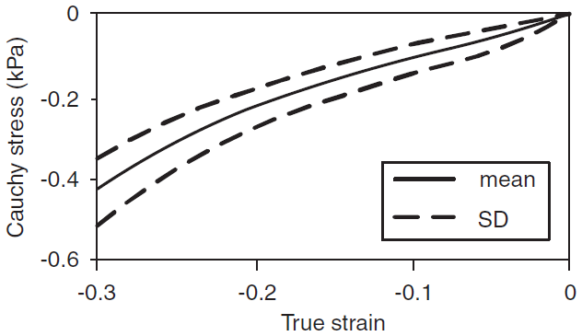

Fig. 1. Figure captions should describe succinctly what is being presented in the figure, axis labels should be legible and units should be included. Colour images may be difficult to interpret if printed in black-and-white. An example of a single figure is shown here.

Fig. 2. For two images side by side, create a 2x2 table in MS Word. Populate with the two images/captions, then make the table borders invisible as instructed above. | Fig. 3. Put figure caption here.

To insert tables in MS Word, position the cursor at the insertion point, click Table on the Insert menu and then choose the desired size of table required. To format the table as shown below, first remove all borders by selecting the whole table, click the right hand mouse button, then click Borders and Shading and choose Setting: none and apply to table. To insert the two horizontal lines shown, first select the first row of the table, click the right hand mouse button, then click Borders and Shading and choose the underscore icon on the right and apply to cell. Then select the last row of the table, click the right hand mouse button, then click Borders and Shading and choose the underscore icon on the right and apply to cell. Minor changes to the proposed table format may be appropriate in some cases.
Figures and/or tables and their captions should be positioned on the same page.

TABLE I
Measured parameters
Symbol | Units | Measured Value
m | Kg | 3.41
t | S | 0-0.05
 | Pa | 1E6-1E8

DISCUSSION
The Discussion should put the results of your work in the context of existing knowledge in the field. Therefore, the Discussion should summarize the significance of your findings and it should highlight anomalies/uncertainties etc. The Discussion should address the strengths and limitations of the work performed.

CONCLUSION
The Conclusions should be limited to what you can actually conclude on the basis of the novel work that you have done and presented in this paper. Conclusions should be succinct and should not overstate the achievements of the work.

ACKNOWLEDGEMENTS
It may be appropriate to thank people for providing data or other assistance. Do this briefly here.

REFERENCES
Give all authors’ names unless there are more than six. In such cases, give the first two authors’ names followed by et al to indicate additional authors. Use a space after authors’ initials. Papers that have been accepted for publication but not yet specified for an issue should be cited as “in press”. Web site references may be used (although not preferred) where a peer reviewed publication is not available and must follow the format noted below. MSc/PhD theses are not acceptable references unless there are no other published references and the theses are readily available. References that are not yet available are not acceptable.
For those using EndNote® or Citavi to manage references we have prepared style templates which are available on our website for download.

Journal article
Author surname, Initial. (Year of publication) Title. Journal, Volume(issue): p.pages.

Web page
Author surname, Initial. “Title”, internet URL. [cited access year access date]

Book
Author surname, Initial. (Year of publication) Book Title, p.pages. Publisher, place of publication.

Conference proceedings
Author surname, Initial. (Year paper written) Title. Proceedings of Conference name, year of conference, conference location.

Report
Author surname, Initial. (Year of publication) Institution name, Report title, place of publication.

[Note: no space between p./pp. and the page numbers, e.g. p.1, pp.2–3
and note also that N-dash is used within spreads of numbers, not a hyphen]

SHORT PAPER: REFERENCES
Please put spaces between the abbreviations of journal titles:
J Biomech Eng
Eur Spine J
Spine Deform

APPENDIX
Appendices, if needed, appear here.

Notes to Authors:

IRCOBI reserves the right to edit and format all conference papers with authors’ final approval.

The first version of the manuscript should be prepared as if it were the final version.

Authors should use the edited version of the manuscript in preparing the final version.

Authors must provide their manuscript in Word format.

F. A. Author is a MSc student in Biomechanics at XXXXX XXXX University in XXX (corresponding author to provide phone and e-mail). S. B. Author is Professor of XXX in the Department of XXX at XXX XXXX University in XXX. If more than one author is affiliated with the same university or organization, name it only once after listing all authors and their titles.

